**Assignment – 1**

|  |  |
| --- | --- |
| Student Name/ID Number: | Syukur Sidiq Nur Alam |
| Unit Number and Title: | Develop Project Proposal |
| Academic Year: |  |
| Unit Assessor: |  |
| Project Title: | Develop Enterprise Applications |
| Issue Date: |  |
| Submission Date: |  |
| Internal Verifier Name: |  |
| Date: |  |

|  |
| --- |
| **Learner declaration** |
|  |
| I certify that the work submitted for this assignment is my own and research sources are fully acknowledged.  Student signature: Date: 27/06/2023 |

**MEALS ON WHEELS**

**Assignment 1 – Project Proposal**



**SOFTWARE ENGINEERING**

**Group-07:**

**Asep Supriyadi (L)**

**Abdul Rahman Shalehudin**

**Ajri Muhammad Sidik**

**Darren Farrell Andrian**

**Syukur Sidiq Nur Alam**

**LITHAN EDUCLAAS**

**(2023)**

1. **Project Introduction**
   1. **Project Background**

The project "Meals on Wheels" aims to provide a comprehensive software solution for MerryMeal, a charitable organization dedicated to delivering nutritious meals to homebound individuals who are unable to cook for themselves due to age, disease, or disability. the project will encompass designing the software, creating a development plan, and implementing a functional application. The service will operate from Monday to Friday, with frozen meals provided over the weekend for members located beyond a 10-kilometer radius. By partnering with food service providers nationwide, MerryMeal seeks to ensure efficient and prompt meal delivery to those in need. As a full-stack web developer at Unity One Solutions, we have been assigned to design and create a software solution for this project.

The application will cater to the following user roles:

1. Members: These are adults who meet the eligibility criteria and require meal services due to age, disease, or disability. They will use the system to register, specify their requirements, and access meal services.
2. Caregivers: Individuals responsible for taking care of the members and assisting them with their food services. Caregivers will use the system to help members register, update information, and coordinate food deliveries.
3. Partners: Food service providers and organizations partnered with Meals on Wheels to support meal delivery operations. Partners will interact with the system to register, provide their details, and collaborate in meal planning, preparation, and delivery.
4. Volunteers: Individuals who volunteer their time and services to assist Meals on Wheels in delivering meals (Volunteer as a driver) or cooking for members (volunteers who have a kitchen). Volunteers will use the system to register, provide their information, and participate in meal-related activities.
5. Donors/Supporters: Individuals or organizations interested in financially supporting the Meals on Wheels project. Donors and supporters will interact with the system to make donations, view fundraising efforts, and learn about the members.
6. Administrators: Staff responsible for managing and overseeing the operations of Meals On Wheels. Administrators will have privileged access to the system, enabling them to manage user accounts, monitor meal deliveries, evaluate needs, generate reports, and ensure effective program management.
   1. **Pain Points**

Business Problem Statement:

1. Data Management Challenge : the efficiency and accuracy in handling and storing data, posing challenges to the project's operations.
2. Poor Food Management and Food Safety: Inadequate food management system and lack of food safety measures can undermine customer trust in the quality and hygiene of the provided food.
3. Lack of Responsiveness and Customer Support: Insufficient responsiveness, politeness, and customer support can negatively affect the brand image and customer satisfaction.
4. Financial Constraints: Limited funds can restrict the project's development, maintenance, and growth.
5. Delivery Driver Training Issues: Insufficient training for delivery drivers can result in uncertainties in deliveries and impact service quality.
6. Limited Customer Interaction: In offline food delivery business, there is limited customer interaction and reach, which can hinder the project's growth and success.

Based on the pain points or business problem statement, a business analysis is conducted to evaluate **external and internal factors** that can impact the project. The SWOT analysis helps identify key strengths, weaknesses, opportunities, and threats associated with Meals on Wheels . These factors are summarized as follows :

1. **Strengths**
2. Unique and cost-effective resources provide a competitive advantage.
3. Market recognizes the company's activities and resources as strengths.
4. Online application saves time for customers.
5. Company offers a distinctive delivery proposition.
6. Online system improves user data management.
7. **Weaknesses**
8. Opportunities to improve the application by addressing bugs and risks.
9. Some activities in the Online Food Ordering System can be optimized.
10. Factors that may negatively impact sales need attention.
11. Competitor activities can pose challenges.
12. **Opportunities**
13. Industry trends offer growth opportunities.
14. Embracing technology and market strategies can open new avenues.
15. Government policy changes can benefit the company.
16. Learning from competitors can drive improvement and innovation.
17. Adapting to changes in social patterns and lifestyles can lead to new services or products.
18. **Threats**
19. Competition and competitor activities pose a threat.
20. Maintaining high product and service quality is crucial.
21. Staying updated with changing technologies is necessary.
22. Financial and cash flow challenges can impact the project.
    1. **Project Objectives**
23. **Analyze Meals on Wheels' business requirements:** Conduct a thorough analysis of Meals on Wheels' operations, procedures, and data to identify their specific needs and challenges in providing meals to members.
24. **Develop an appropriate software solution**: Based on the analysis, propose and create a detailed design plan and blueprint for the software solution. This includes defining the system architecture, user interface design, UI/UX plan, storyboards, database structure, and other technical specifications to ensure a solid foundation for development.
25. **Implement a functional business application:** Develop the software solution according to the finalized design plan, considering the waterfall model's sequential approach. This involves coding, testing, and integrating various components to create a fully functional application that meets Meals on Wheels' requirements.
26. **Evaluate application performance and identify improvements:** Assess the application's performance against its intended goals, ensuring that it aligns with the design specifications. Analyze factors influencing performance, identify any shortcomings, and provide recommendations for improvement in subsequent iterations or phases of the project.
    1. **Project Goals**

The project aims to provide nutritious meals to eligible adults through Meals on Wheels. This involves partnering with food and donation service providers for efficient meal delivery. A dedicated sitter manages the food service, while riders ensure timely delivery. The project also encourages volunteer and partner involvement to support the charitable cause. Ultimately, the goal is to make a positive impact by providing meals, fostering community engagement, and ensuring reliable service delivery.

* 1. **Project Scope**

**System Overview -** The application will have the following functionality:

1. Members and Caregivers registration with their requirements
2. Partners and Volunteers registration with their details
3. Fund raising through Donors / Supporters
4. Menu Planning and Preparation
5. Meal Delivery Management of partners and riders
6. Food Safety Management
7. Reassessment of need evaluation, and,
8. Management Information System for effective management
9. **Project initiation** 
   1. **Project Stakeholder**

2.1.1 What are project stakeholders ?

Stakeholders are individuals, groups, or organizations with an interest or impact on a project's outcome. They can be internal or external, and their needs and expectations must be understood and managed for project success. Effective stakeholder management involves identifying them, communicating regularly, addressing concerns, and involving them in decision-making. By engaging and collaborating with stakeholders, project managers gain support, mitigate risks, and ensure project outcomes align with stakeholder requirements. This active management enhances project outcomes and minimizes conflicts or resistance during implementation.

2.1.2 Identification of Key Stakeholders:

Internal Stakeholders

|  |  |  |  |
| --- | --- | --- | --- |
| **No** | **Role** | **Description** | **Name** |
| 1 | Project Manager | Implementing project management strategy to achieve the project objectives, & A leader who manages a specific team. | Mr. David |
| 2 | Team Members & Application manager | Employees who work as a team to handle all tasks assigned by manager. | Abdul,  Ajri,  Asep,  Darren,  Syukur, |

**External Stakeholders**

|  |  |  |
| --- | --- | --- |
| **No** | **Role** | **Description** |
| 1 | Member | Qualified person who use apps to Request food. |
| 2 | Caregiver | whose job is to deliver food to members. |
| 3 | Partner | A business partner who serves meals to members. |
| 4 | Volunteer | Those who will join the volunteers |
| 5 | Donor | Those who will provider economic support to the company |
| 6 | Driver | Those who will join the driver |

* 1. **Feasibility study (Group)**
     1. **Technical Feasibility**

A technical feasibility assessment examines the available technological resources for our project. This investigation analyzes whether we have the necessary equipment, tools, and technical knowledge to achieve our project objectives**.**

* + - 1. **Hardware, Software and Network requirement**
  1. **Hardware Requirement**

|  |  |  |  |
| --- | --- | --- | --- |
| **No** | **Hardware** | | |
| **Type** | **Service** | **Client** |
| **1** | Processor | Intel i5 2.6 GHZ | Intel-i3 our above |
| **2** | Memory | 12GB | 4GB our above |
| **3** | Hard Drive | 4TB SSD NVME | 1TB our above |
| **4** | Network | Gigabit Network | Wifi / Internet Providers |

**B. Software Required**

|  |  |  |
| --- | --- | --- |
| **No** | **Software** | |
| **Software Device** | **Functionality** |
| **1** | Window 10 | Operating System |
| **2** | Visual code, eclipse,spring boot | Web Creation |
| **3** | Tomcat | Web server |
| **4** | MySQL | Databases |
| **5** | Figma | Design |
| **6** | Google,Chrome,microsoft edge | Web Browser |

**C. Network Requirements**

|  |  |  |
| --- | --- | --- |
| **No** | **Network** | |
| **Network Device** | **Functionality** |
| **1** | Switch | Cable connecting network from workstation |
| **2** | UTP Cable | Connecting Medium |
| **3** | RJ 45 Connector | Cable connecting network with LAN Card |

* + - 1. **Familiarity with application and Technology**
* **Familiarity with application**

Based on the scenario of the applications, particularly from our experience with the Meals on Wheels project, we have a strong understanding of the features and requirements associated with the “Meals on Wheels ” application. This knowledge allows us to identify user needs and design the application accordingly, leveraging technologies like JavaScript, Java, React, and Spring. Additionally. With this knowledge, we are confident in our ability to develop an effective and efficient application that meets the needs and expectations of users.

* **Familiarity with technology**

we have a good understanding of the capabilities and features offered by this technology. we have developed web applications using JavaScript and React, for the frontend and developed backend applications using Java and Spring with this we can adapt in implementing the features needed in this application

* + - 1. **Project Size**

We will develop an online food delivery system that involves features such as user registration, login system, food ordering, order management, and delivery notifications. The project will also involve developing a responsive and intuitive user interface, as well as integration with online payment systems. With these various features, this project is considered to be quite large and complex in size. Therefore, it will require significant team effort in terms of development, testing and implementation to ensure the success of this project within the specified timeline.

* + 1. **Operational feasibility**

The operational viability of a project determines whether your firm has the necessary resources, skills, and competences to finish it. It entails assessing workforce needs, organizational structure, and any legal implications. The operational feasibility assessment determines whether your team is capable of completing the project and whether you have the necessary resources and competencies.

### **Operational Feasibility**

|  |  |  |
| --- | --- | --- |
| **No** | **Operational Feasibility** | |
| **Requirements** | **Description** |
| **1** | **Performance** | * The system is capable of handling a high volume of simultaneous requests, serving up to 1,000 requests at the same time. * The performance parameter will be evaluated based on response time, throughput, and scalability. |
| **2** | Information | * More accurate information with an accuracy of 5 decimal places. * The accuracy of data will be assessed based on comparison with trusted sources and data validation techniques. |
| **3** | Economy | * The system implementation will lead to cost savings as error reporting can be minimized, reducing potential financial losses. |
| **4** | Control | The system will enforce strict user access control measures to maintain data security and prevent unauthorized access. |
| **5** | Efficiency | The system will save time by avoiding redundant data entry through the use of a centralized database. |
| **6** | Services | The system will enhance service quality by presenting information consistently across all interactions. |
| **7** | Operational Feasibility Value | Locally based system (for organizations only), with Layout common as possible, so it has a value of 8.5. |

based on the operational feasibility that we analyzed, we can get some conclusions which are mentioned below :

1. Will the users use the proposed system ?

Yes, users are likely to use the proposed system because it addresses their needs, improves accuracy, efficiency, and service quality, and provides a consistent format for information presentation.

1. What skills are required for all of the teams member to develop this project ?

Users may need to acquire or enhance skills related to using the system's interface, understanding the workflow, and adapting to new data entry processes. Training on system security and user access control may also be required.

1. How long will it take to retrain the team members to adapt to the new system ?

The duration of all team members retraining will depend on factors such as the complexity of the system, the size of the user base, and the availability of training resources. Generally, it can range from a few days to several weeks to ensure a smooth transition and provide enough time for practice and support.

* + 1. **Economic feasibility**

The economic feasbility is essential to know the budget needed for the completion of the application, and how much income be able to generate once realeased the necessarry budget for this project is low. The technologic for needed for this project are free to use.

**Cost Benefit Analysis**

* + - * **Cost analysis**

|  |  |  |
| --- | --- | --- |
| List of cost needed | Description of activity | Total cost in month |
| Requirement gathering | Activities to gather and document project requirements, including meetings with stakeholders, interviews, research, and analysis. | $400 |
| Hardware | Procurement and installation of a 4TB hard drive for data storage and processing requirements. | $1.500 |
| Software | Purchase or licensing of necessary software tools and applications required for the project development and execution. | $1.200 |
| Hosting | Subscription or rental fees for hosting services, including web servers or cloud infrastructure to deploy and host the application. | $200 |
| Maintenance | Ongoing support, updates, bug fixes, and enhancements to ensure the system's functionality, security, and performance. | $800 |
| Design Implementation | Implementation of the design elements, including user interface (UI) design, user experience (UX) design, and visual design. | $3.000 |
| Human resource | Costs associated with hiring and retaining personnel for project development and management, including salaries, benefits, and training. | $3.000 |
| Marginal / urgent cost | Additional costs that may arise unexpectedly during the project's lifecycle, such as hardware or software upgrades, unforeseen requirements, or urgent fixes. | $400 |
| Total cost | Total cost The sum of all the costs listed above, representing the total expenditure required for the project. | $21.000 |
| Total cost expected |  | $20.000 |

* **Benefit analysis**

|  |  |  |
| --- | --- | --- |
| Benefit gotten |  | Const / Month |
| Direct benefit | $5.000 amount now $25.000 as donation | $25.000 |
| Indirect benefit | Overall perfomance on the websiteis $500, now $1000 | $1000 |

* **Return in investment**

Total Value = 32000

= around 23% return in investment profit

* + - 1. **Direct Cost and Benefit**

Tangible and intangible cost and benefit as following:

* + - * Tangible cost:

Tangible costs for the project include expenses such as the procurement and installation of a 4TB hard drive for data storage ($1,500), the purchase or licensing of necessary software tools and applications ($1,200), subscription or rental fees for hosting services ($200), ongoing support and maintenance ($800), implementation of design elements ($3,000), human resource costs ($3,000), and any additional marginal or urgent costs that may arise ($400). These costs can be measured and quantified in monetary terms.

* + - * Tangible benefit:

On the other hand, tangible benefits for the project include a direct benefit of $25,000, representing a generous donation received, and an indirect benefit of $1,000, resulting from an improvement in the overall performance of the website. These benefits can be easily quantified and measured in terms of their monetary value.

* + - * Intangible cost:

the requirement gathering process, which incurs a cost of $400. This cost is considered intangible because it is difficult to directly quantify or measure in monetary terms. Intangible costs may involve factors such as time investment, effort, or resources allocated to activities that do not have a direct monetary value.

* + - * Intangible benefit:

Intangible benefit will occurs when the investment of the design implementation ($3,000) and ongoing maintenance ($800) of the project, the intangible benefit of improved user experience can be expected. A well-designed user interface (UI) and user experience (UX) can lead to enhanced user satisfaction, ease of navigation, and intuitive interaction with the application or website.

* + 1. **Schedule feasibility**

­­Feasibility schedule in this project “Meals on Wheels” make sure that the meal Scheduling feasibility is essential to ensure that food can be provided to target groups in a timely and regular manner. We divide it into a different task that need to be considered in determining the affordability of the schedule include:

1. Week 1 - Initiation Phase (6/12/23 until 6/16/23):

* Conduct interviews and meetings with Meals on Wheels stakeholders to understand their needs and objectives.
* Analyze Meals on Wheels business plan and identify specific requirements for the software application.
* Validate and prioritize requirements with stakeholders.
* Assess the feasibility of the project based on available resources, budget, and timeline.
* Create a detailed project plan and timeline, considering resource allocation, task dependencies, and milestones.

1. Week 2 Design and Development Planning (6/19/23 until 6/23/23):

* Develop design recommendations and strategies that align with Meals on Wheels business plan and requirements.
* Define the system architecture and technology stack to be used.
* Obtain necessary approvals and ensure alignment with stakeholders.
* Start designing the flow diagram, UML, ER Diagram

1. Week 3 Application Development (6/23/23 until 6/5/23):

* Set up the development environment and infrastructure.
* Implement backend functionality using Java Spring Boot and RESTful APIs.
* Develop frontend components using React.js, React Bootstrap, HTML, and CSS.
* Integrate frontend and backend systems.
* Implement specific features, such as member and caregiver registration, partner and volunteer registration, fundraising module, menu planning, meal delivery management, food safety management, reassessment and evaluation system, and management information system.

1. Week 4 Monitoring / Controlling (6/5/23 until 6/7/23):

* Create comprehensive test cases based on the defined requirements.
* Perform functional testing to ensure the application meets the specified criteria.
* Conduct integration testing to verify the seamless interaction between different system components.
* Identify and resolve any bugs or issues discovered during testing.
* Conduct user acceptance testing with stakeholders to ensure the application meets their expectations such as Unit Testing, UAT, performance, compatibility, etc.

In conclusion, the feasibility schedule for the "Meals on Wheels " project outlines the necessary tasks and phases to develop and implement the software application successfully. It includes stages such as feasibility study, design and planning, development, testing, and deployment. By following this schedule, the project aims to meet Meals on Wheels objectives and deliver a functional application within the allocated time and resources.

* + 1. **Risk Feasibility**

List of possible risk feasibility will be conducted:

* **Technology Risk:** Technology risk involves challenges or issues related to the technology used in the development process. This could include issues such as compatibility problems between different software or hardware components, limitations of chosen technologies, or reliance on outdated or unsupported technologies. The likelihood of this risk occurring is rated at 4, and the consequence is rated at 5, resulting in an extreme level of risk. To address this risk, conducting thorough testing and quality assurance measures throughout the development process to identify and address any technological issues is a must. Additionally, staying updated with the latest technological advancements and best practices to ensure the application is built using robust and reliable technologies.
* **Physical Risk:** Physical risk refers to risks associated with the physical infrastructure, hardware, and equipment used in the development process. This can include risks such as equipment failure, damage, or loss due to accidents, natural disasters, or security breaches. The likelihood is rated at 2, and the consequence is rated at 5, leading to a high-risk level. To address this risk, ensuring a safe physical workspace for team members by implementing appropriate safety measures and protocols. Regular equipment maintenance and backups will be conducted to prevent data loss or hardware failures. Additionally, securing appropriate insurance coverage to mitigate financial losses in case of physical damage.
* **Human Factor Risk:** Human factor risk encompasses risks arising from human error, lack of expertise, or inadequate collaboration and communication within the development team. This can include challenges in project management, resource allocation, skill gaps, or team dynamics that may affect the successful completion of the application. The likelihood is rated at 4, and the consequence is rated at 4, resulting in an extreme level of risk. To address this risk, providing comprehensive training and onboarding programs for the development team to enhance their skills and knowledge. Regular communication, collaboration, and feedback sessions will be conducted to address any concerns, ensure clarity, and promote a culture of continuous improvement.
* **Political Risk:** Political risk involves risks associated with changes in political landscapes, government regulations, or policies that could impact the development and deployment of the application. This can include the possibility of restrictions, bans, or legal obstacles imposed by governments or regulatory bodies that may affect the project's scope or viability. The likelihood is rated at 1, and the consequence is rated at 3, resulting in a low-risk level. To address this risk, staying informed about political landscapes, regulations, and policies is crucial. Establishing strong relationships with relevant authorities and industry experts can help navigate potential obstacles. Having a contingency plan that includes alternative strategies and diversifying the project's scope can provide flexibility in case of political changes.
* **Natural Risk:** Natural risk pertains to risks related to natural disasters or environmental factors that could disrupt the development process. This includes events such as earthquakes, floods, storms, or other natural calamities that could damage physical infrastructure, result in data loss, or disrupt operations. The likelihood is rated at 1, and the consequence is rated at 4, resulting in a moderate level of risk. To address this risk, implementing disaster preparedness plans is essential. This includes creating backup systems and data storage, conducting regular safety drills, and establishing communication protocols for emergencies. Collaborating with local authorities, insurance providers, and risk management experts can help develop effective response plans and mitigate potential disruptions.
* **Economic Risk:** Economic risk involves risks arising from changes in economic conditions, market fluctuations, or financial constraints that could impact the development project. It includes factors such as budget limitations, unexpected cost increases, or changes in resource availability. The likelihood is rated at 2, and the consequence is rated at 3, leading to a moderate level of risk. To address this risk, conducting thorough financial planning and monitoring is crucial. This includes regular budget reviews, cost tracking, and exploring alternative funding options. Developing contingency plans and maintaining good relationships with suppliers and vendors can help mitigate the impact of economic fluctuations or unexpected cost increases.
  + 1. **Legality Feasibility**

Legal feasibility is the feasibility of legality or legal force. This means that the proposed information system may not contradict applicable legislation, whether determined by the government or formed by law in accordance with organizational regulations.

* Intellectual Property Rights: Care should be taken to respect intellectual property rights when using third-party software, content, or designs in the project. Proper licenses or permissions should be obtained to avoid legal issues.
* Data Privacy and Security: The project should comply with applicable data privacy regulations to protect the personal information of members, volunteers, and donors. Implementing measures such as secure data storage, consent management, and encryption will be essential.

By analyzing legal feasibility, the project can operate within legal boundaries and protect the interests of all stakeholders involved.

* 1. **UI/UX Design Consideration (Individual)**

In our project, I have specific tasks assigned to me. I will identify UI/UX considerations based on my responsibilities. My focus areas include a login system with role-based access control as partner management. With these aspects in mind, I aim to create an intuitive and visually appealing interface that ensures smooth navigation, clear content presentation, and efficient functionality for partners. I divided the UI/UX considerations into the following areas:

**1. Menu Bar (Navbar):**

- Navigation UI/UX: Ensure the menu bar is easy to understand and navigate for partners.

- Use clear labels and intuitive icons to represent different sections or actions.

**2. Content:**

1. Layout and Design Clarity:

- Organize the content in a logical and structured manner for easy access.

- Ensure important information is prominently displayed and easily readable.

2. Functionality:

- Consider partner-specific functionalities and features that align with their needs.

- Ensure the interface supports partner-related actions such as managing orders or accessing partnership resources.

3. Responsiveness:

- Ensure the content and interface adapt well to different devices and screen sizes.

- Prioritize mobile responsiveness to cater to partners accessing the system on their smartphones or tablets.

4. Performance:

- Optimize the system's performance to ensure quick loading times for partners.

- Minimize any delays or lag that may hinder partners from efficiently completing their tasks.

**3. Visual Design:**

1. Unity:

- Maintain a consistent visual style throughout the interface to provide a cohesive experience.

- Use consistent branding elements and color schemes related to the partnership.

2. Balance:

- Ensure a balanced distribution of elements on the screen to avoid visual clutter.

- Prioritize important information and actions based on their relevance to partners.

3. Contrast:

- Use contrasting colors to differentiate important elements and improve readability.

- Ensure sufficient contrast between text and background to enhance legibility.

4. Scale:

- Utilize appropriate sizing for elements to establish visual hierarchy and guide partners' attention.

- Ensure consistency in sizing across different partner-related components.

5. Dominance:

- Emphasize key partner actions or information using size, color, or placement techniques.

- Highlight important calls to action or alerts to ensure partners can easily identify them.

**In conclusion**, my focus areas for UI/UX considerations include intuitive navigation, clean content layout, smooth functionality, responsive design, and visually appealing visual design. By prioritizing these aspects, I aim to create an interface that ensures easy access to management functionalities, clear presentation of content, efficient controls for managing tasks, responsiveness across devices, and a visually cohesive and engaging design.

* 1. **Dependencies** 
     1. **Logical dependencies**

This dependency is critical for project completion and is a component of the project.

* Menu planning and food preparation: Menu planning should be related to proper food preparation.
* Member and caregiver requirements and reassessment: Member and caregiver requirements must be updated regularly.
* Meal delivery management and partners/volunteers registration: Management of food delivery depends on registered partners and volunteers.
* Food safety management and menu planning/preparation: Food safety must be a concern in menu planning and preparation.
* Fundraising and management information system: Financial and supporting information must be integrated with the management system for effective fundraising
  + 1. **Resource dependencies**

Resource dependency are driven by constraint

* Human resources, such as skilled workers in farming, cooking, or volunteers/ support roles.
* Financial resources are crucial for funding the procurement of food, operational expenses, infrastructure, promotion, and project development.
* Physical resources, such as agricultural land, kitchen or food production facilities, storage facilities, and cooking equipment, are necessary for the project's operations.
* Technological resources, like food processing systems or project management software, and time resources for effective scheduling and allocation are also important.
* Additionally, knowledge and information resources, including food research, nutritional guidelines, and best practices in project management, play a role in decision-making and innovation.
  + 1. **External dependencies**

Based on outside factor and unexpected event

* Natural disasters: Delays in food delivery caused by unforeseen natural disasters, such as earthquakes, floods, or storms.
* Economic fluctuations: Affordability and accessibility of food resources affected by sudden economic changes, leading to challenges in maintaining the supply chain within budget constraints.
* Political instability: Uncertainties in the regulatory environment due to political instability or changes in government policies, requiring adjustments to comply with new regulations.
* Public health crises: Disruptions in external dependencies caused by unexpected public health crises like pandemics, affecting the availability of food resources and the project's ability to reach the target population.
* Socio-cultural shifts: Adaptations in external dependencies to address rapid socio-cultural changes or shifts in dietary preferences and trends.
  1. **Project Assumptions** 
     1. **Resources**

Possible resource will be taken in Meals on Wheels Application

* Human resources: Skilled developers, designers, and testers will be required to develop and maintain the Merry Meals application.
* End members: The target beneficiaries of the Merry Meals Application. These are elderly or disabled individuals who will receive free meals through the application. Consider the number of end members that the application aims to serve and the potential demand for their specific needs.
* Volunteers: Partner volunteers who will cook the meals and caregiver volunteers who will deliver the food to the members.
* Donors: The application assumes the availability of donors who will fund the meals cooked by the partner volunteers.
  + 1. **Finance**

Possible finance will be taken in Meals on Wheels Application

* Company finances: Adequate funding will be necessary to cover the operational costs of the company, including expenses related to the procurement of food supplies, transportation, maintenance of the application, and any other necessary expenses to support the operations of Meals on Wheels.
* Donor funding: The application assumes the availability of donors who will contribute financial resources to support the provision of free meals to the elderly or disabled individuals. These funds will be utilized for procuring the necessary ingredients and supplies for the partner volunteers to prepare the meals.
  + 1. **Partner**
* Meals on Wheels food production compliance: The food production process for Meals on Wheels will adhere to the Food Safety System Certification (FSSC) standards to ensure the safety and quality of the meals.

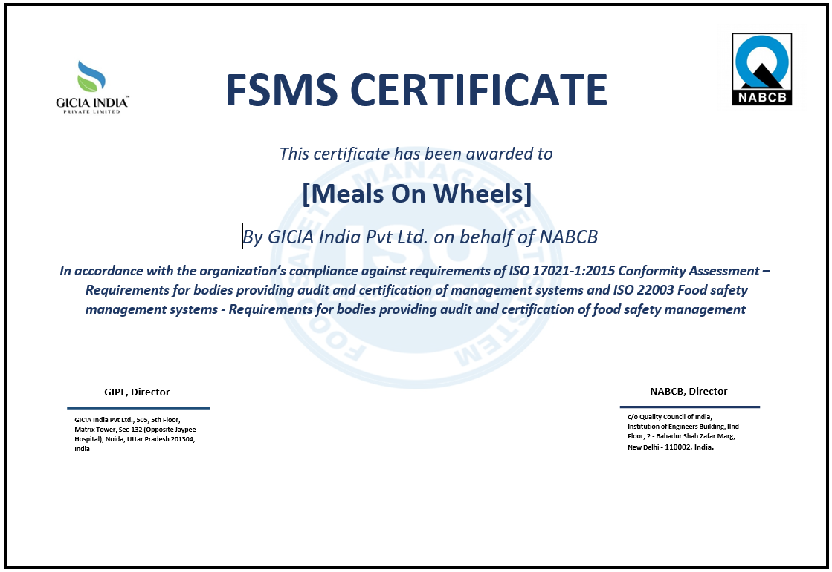

*Notes: This is fake certificate, just for example*

* HALAL certification: The meals provided by Meals on Wheels will have HALAL certification to comply with halal regulations and cater to the dietary preferences of the target beneficiaries.



* + 1. **Project**
* Meals on Wheels Website: The Meals on Wheels application will have a website component that will require ongoing maintenance and updates.
* SSL Certification: The application will have SSL certification to ensure secure and encrypted communication between users and the server.
* Daily backups: The application's data will be backed up every day within a 10-hour timeframe to prevent data loss in case of any issues.
* Project timeline: The assumption is that the project will take approximately one month to complete the development phase, followed by testing conducted by the developers.
  1. **Project Constraint**

Project constraints refer to the limitations or restrictions that affect the planning, execution, and completion of a project. Common types of project constraints include:

* + 1. **Client**
* Hot meals can be delivered under a radius 10 KM.
* Frost meals can be delivered above a radius 10 KM.
* Service only available every day except Saturday and Sunday.
* Different ages of customers will be considered in developing the Meals on Wheels website in order to avoid misleading or misunderstanding stuff.
  + 1. **Time**

Meals on Wheels Project website must be developed within 1 month, of which 2 weeks or more is used to carry out project analysis to make project plans, designs etc, and the rest to carry out project implementation

* + 1. **Scope**
* The project scope, as outlined in the project overview, must be strictly adhered to. Any changes or additions to the functionality or features may require proper assessment, approval, and potential adjustments to the project timeline and budget.
  + 1. **Cost**
* The Meals on Wheels project’s budget is around $25.000, Any cost growth beyond the calculated budget may impact the scope of the project, potentially resulting in the exclusion of certain features or functionalities.
  + 1. **Resources**
* The process of developing the projects itself has limited resources software tools, and hardware infrastructure. These resources need to be effectively managed and utilized to meet project requirements.
  + 1. **Environment**
* Convenience workplace for developer teams.
* Each every team members must have an effective communication channels and collaboration for seamless coordination among team members, stakeholders, and other relevant parties.
* Maintaning workload balance by scheduling each every team members task for team productivity
  + 1. **Skill**
* Backend Development Skill: Proficiency in Java Spring Boot, RESTful API development, and database management.
* Frontend Development Skill: Proficiency in React.js, React Bootstrap, HTML, CSS, and frontend state management.
* Full-Stack Development Skill: Proficiency in both backend and frontend development for efficient coordination and integration.
* Project Management: Skilled project manager or team lead for overseeing tasks and ensuring effective communication.
* Quality Assurance and Testing: QA professionals with expertise in testing frameworks and tools for thorough application testing.
  + 1. **Man Power**
* Team members are proficient in Java, Spring Boot
* Team members are proficient in Javascript, React
* Team members have experience in full stack web development.
* Team members who possess good project management skills.
* Team members who have expertise in application testing.

These constraints often interact with each other and require careful management and trade-offs to ensure project success.

* 1. **Project Milestone: Progress to measure to achieve goals**

Project milestones are important events or achievements that track a project's progress. They provide a visual representation of the project schedule and help communicate the project's advancement to stakeholders. Milestones are useful for keeping everyone informed, including project team members, managers, clients, and investors. They also initiate key actions like approvals, resource allocation, and budget releases. Overall, milestones are valuable for monitoring project health, managing stakeholder expectations, and celebrating accomplishments. the milestone from planning to completion mention below :

* + 1. **Requirement gathering**

Requirement gathering involves collecting and documenting the needs and expectations of stakeholders. This is done through interviews, meetings, surveys, and analyzing existing documentation or according to the Meals on Wheels project manager. The gathered requirements are then organized, prioritized, and validated with stakeholders. A comprehensive requirements document is created, which undergoes review and finalization. It's an iterative process that requires effective communication and collaboration to ensure accurate and complete requirements.

We analyze the requirements based on the functional and non-functional requirements mentioned below:

**Functional Requirement:**

Functional requirements define the specific functions and capabilities that the software application should possess. These requirements describe what the system must do and how it should behave to meet the needs of its users. Based on the project scope, here are some functional requirements ordered:

* The application should allow new members and their caregivers, volunteers or any user to register by providing necessary personal information.
* The application should facilitate online donations and allow donors to contribute funds to support the organization's activities.
* The application should provide tools for planning and managing menus, including options for creating, modifying, and deleting meal options.
* The application should enable efficient management of meal deliveries, including assigning drivers or riders, tracking delivery status, and providing real-time updates to members and caregivers.

**Non-functional Requirements:**

Non-functional requirements are related to the overall characteristics and qualities of the software application, rather than specific functionalities. They describe how the system should perform, the constraints it should adhere to, and other quality attributes. Here are some examples of non-functional requirements based on the project scope:

* **Performance :** The application should be responsive and provide quick response times to user interactions, even with high concurrent user traffic.
* **Security :** The application should implement robust security measures to protect personal information, donations, and sensitive data from unauthorized access or breaches.
* **Usability:** The application should have an intuitive and user-friendly interface, making it easy for members, partners, and volunteers to navigate and perform tasks efficiently.
* **Reliability:** The application should be stable and available for use during the designated service hours, ensuring uninterrupted access for members, partners, and volunteers.
* **Scalability:** The application should have the ability to handle an increasing number of users, accommodate future growth, and support additional functionalities as the organization expands.
  + 1. **Validate expectations for requirements**

After listing all the requirements requested from the project manager, we clarified the expected requirements which are really required, the way we carry out the verification is mentioned below:

* Review the gathered requirements with stakeholders, including members, partners, volunteers, and the project manager, to ensure they align with their expectations.
* Confirm that the proposed functionalities address the needs of the charitable organization and support their business plan.
  + 1. **Predevelopment planning**

After validating the requirements, the project manager will assign each team member their task, each team member task which is mentioned below:

|  |  |
| --- | --- |
| Team Member’s Name | Task Assigned |
| Abdul Rahman Shalehudin | Handle the functionality of Driver |
| Ajri Muhammad Sidiq | Handle the functionality of Volunteer |
| Asep Supriyadi | Handle the functionality of Administrator |
| Darren Farrell Andrian | Handle the functionality of Member and Donor |
| Syukur Sidiq Nur Alam | Handle the functionality of Partner |

* + 1. **Implementation**

After dividing every tasks to each team member, we start the implemention of the project according to their respective tasks, the process of how we do the implementation are mentioned below :

* Develop the software application based on the functional requirements identified in the proposal.
* Implement features such as member and caregiver registration, partner and volunteer management, donation processing, menu planning, meal delivery management, food safety management, reassessment of needs, and a management information system.
  + 1. **Quality Assurance testing**

After the completion of the implementation we conduct quality assurance testing to measure that a project meets predefined quality standards, the way conduct quality assurance testing are mentioned below :

* Conduct a precise testing of the developed application to ensure it meets the specified requirements and functions correctly.
* Test a particular scenarios such as member registration, partner and volunteer management, donation processing, menu planning, meal delivery, and data management is it meet the requirement or not.
  + 1. **User Acceptance testing**

We also conduct the User Acceptance Testing (UAT) is done to ensure that the system meets the requirements and expectations of end users or clients before it is deployed. It allows users to test the system and provide feedback to verify its usability, functionality, and overall readiness for production. UAT helps ensure that the system is user-friendly and aligned with user needs. The way we conduct the UAT testing are mentioned below:

* Involve members, partners, volunteers, project manager, or any other stake holders to test the application to ensure it meets their expectations.
* Allow them to provide feedback on the usability, functionality, and overall user experience of the application.
  + 1. **Deployment**

After conducting some test into the application, so that we can say this project is meet the requirement and ready for the deployment.

* + 1. **Support**

After the project has been deployed, Meals Meal's developer team will continue to provide support for it for the predetermined amount of time.

* 1. **Project deliverables** 
     1. **Internal deliverables**
* Web Design Proposal: The deliverable will include adopting a web design proposal that aligns with Meals on Wheels business plan. The proposal should focus on creating an intuitive and user-friendly interface for members, partners, and volunteers to navigate the application easily.
* Software Design Document (SSD): The deliverable will involve adopting a Software Design Document that outlines the technical design of the software application. It should address the specific requirements of Meals on Wheels , such as member registration, donation management, menu planning, meal delivery, and other functionalities.
  + 1. **External deliverables**
* Enterprise Web Application: The deliverable will consist of developing a functional enterprise web application that supports Meals on Wheels operations in providing hot noon meals to qualifying adults. It should include features like member registration, donation management, menu planning, meal delivery management, management information system, etc.
* User Documentation: The deliverable will involve creating user documentation that provides instructions and guidance on how to use the web application effectively. It should cover topics such as member registration, donation processes, menu planning, meal delivery management, and any other relevant aspects.
  + 1. **Planning deliverables**
* **Project Scope:** The deliverable will define the scope of the project, outlining the specific functionalities and features that will be included in the enterprise web application. It should cover areas such as member registration, donation management, menu planning, meal delivery management, food safety management, reassessment of need evaluation, and the management information system.
* **Budget:** The deliverable will include an estimation of the project's budget, considering the resources required for software development, infrastructure, and any other associated costs.
* **Project Schedule:** The deliverable will outline the project's timeline and milestones, specifying the duration for each phase of development, including design, development, testing, and deployment.
  1. **Functional description (Group)**

|  |  |  |  |
| --- | --- | --- | --- |
| No | User type | Description | Roles based access |
| 1 | Member | Meals on Wheels customer who requests meals, typically adults who are qualified and in need of assistance due to age, illness, or disability. | * Register * Login * Order and view meal * Update profile, view meals track * Send feedback / evaluations |
| 2 | Care giver/Drivers | Meals on Wheels support teams or volunteer who has resposibility to deliver the meals to the members. | * Register * Login * View all food delivery schedule * Update delivery status (Pick Up, On the way, completed) * Edit or view profile page |
| 3 | Partners | These are individuals or organizations that collaborate with Meals on Wheels by providing kitchen facilities and agreeing to process meals according to Meals on Wheels specifications. | * Register * Login * View meals * Process the ordered meals |
| 4 | Volunteers | Participate in Charity activity that’s done by Meals on Wheels Organization, this user can either be a Driver or prepare the food if they have a kitchen | * Register * Login * Based on the roles that they choose, either as a caregiver or rider, they are able to access its role. |
| 5 | Donor / supporter | Individuals or organizations who contribute donations or financial support to Meals on Wheels . | * Register * Login * View & Edit profile * Send donations |
| 6 | Administrator | The one who manage all processes, including meal processing, menu creation, driver assignments, and member coordination, to ensure efficient operations. | * Register * Login * Manage donation * Manage member * Manage menu / order * Manage driver * Manage information systems |

* 1. **Risk analysis and description** 
     1. **Identify possible area of risk in the application development**

In the context of application development, it is important to identify potential areas of risk that could impact the success of the project. The identified risk areas are categorized into internal and external risks.

* + - 1. **Internal risk**

Internal risks are those that originate within the organization or project team. In the context of application development, three primary internal risks are identified:

* **Technology Risk**

Technology risk involves challenges or issues related to the technology used in the development process. This could include issues such as compatibility problems between different software or hardware components, limitations of chosen technologies, or reliance on outdated or unsupported technologies. Such risks can impact the performance, functionality, or stability of the application being developed.

* **Physical Risk**

Physical risk refers to risks associated with the physical infrastructure, hardware, and equipment used in the development process. This can include risks such as equipment failure, damage, or loss due to accidents, natural disasters, or security breaches. Ensuring the physical security and stability of the development environment is crucial to mitigate these risks.

* **Human Factor Risk**

Human factor risk encompasses risks arising from human error, lack of expertise, or inadequate collaboration and communication within the development team. This can include challenges in project management, resource allocation, skill gaps, or team dynamics that may affect the successful completion of the application. Addressing these risks involves effective team management, training, and fostering a culture of open communication and collaboration.

* + - 1. **External Risk**

External risks are factors that originate from outside the organization or project team. In the context of application development, three primary external risks are identified:

* **Political Risk**

Political risk involves risks associated with changes in political landscapes, government regulations, or policies that could impact the development and deployment of the application. This can include the possibility of restrictions, bans, or legal obstacles imposed by governments or regulatory bodies that may affect the project's scope or viability.

* **Natural Risk**

Natural risk pertains to risks related to natural disasters or environmental factors that could disrupt the development process. This includes events such as earthquakes, floods, storms, or other natural calamities that could damage physical infrastructure, result in data loss, or disrupt operations. Implementing disaster preparedness plans and data backup strategies can help mitigate these risks.

* **Economic risk**

This risk involves risks arising from changes in economic conditions, market fluctuations, or financial constraints that could impact the development project. It includes factors such as budget limitations, unexpected cost increases, or changes in resource availability. Conducting thorough financial planning, monitoring costs, and exploring alternative funding options can help mitigate this risk

* + 1. **Analyze and Evaluate**

|  |  |  |  |
| --- | --- | --- | --- |
| **No** | **Risk type** | **Risk description** | **Risk Impact** |
| **1** | Technological | Poor quality code when developing application | If the code quality is poor, it can result in software defects, system crashes, and compromised functionality, leading to a negative user experience and increased maintenance efforts. |
| **2** | Human Factor | human error, lack of expertise, or inadequate collaboration and communication within the development team | If there is a lack of communication and coordination, it can lead to misalignment of tasks, misunderstandings, delays, and errors in the development process. |
| **3** | Economic | Unexpected budget constraints | If there are unexpected budget constraints, it can impact resource allocation, limit the scope of the project, and potentially hinder the successful completion of all planned features and functionalities. |
| **4** | Physical | Damage or loss of hardware or infrastructure | If there is damage or loss of hardware or infrastructure, it can disrupt the development process, cause data loss, and result in delays in the project timeline. |
| **5** | Natural | Natural disaster affecting the development environment | If a natural disaster occurs and affects the development environment, it can lead to disruptions, damage to infrastructure, and loss of resources, potentially causing significant delays and setbacks in the project. |
| **6** | Political | Government banning a software or platform used in the project | If one of the software or platforms used in the project is banned by the government, it can result in the need to find and adapt to an alternative solution, causing delays in the project timeline and potentially requiring significant adjustments in the development process. |

* + 1. **Prepare Risk Matrix**

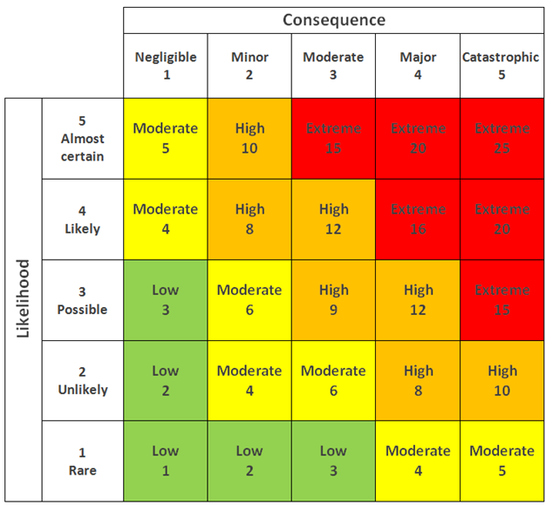

|  |  |  |  |  |  |  |
| --- | --- | --- | --- | --- | --- | --- |
| **No** | **Risk type** | **Risk description** | **Likelihood (1-5)** | **Consequence (1-5)** | **Risk rating** | **Risk level** |
| 1 | Technological | Poor quality code when developing the application. This can occur due to project underestimation or developers rushing to complete iterations, leading to stakeholder dissatisfaction. | 4 | 5 | 20 | Extreme |
| 2 | Human Factor | Insufficient expertise in handling complex project requirements. | 4 | 4 | 16 | Extreme |
| 3 | Economic | Unexpected cost increases due to changes in market conditions or resource availability. | 2 | 3 | 6 | Moderate |
| 4 | Physical | Disruption of the workspace due to equipment failure or damage. | 2 | 5 | 10 | High |
| 5 | Natural | Natural disaster could cause significant damage to the workstation and result in the loss of human resources. | 1 | 4 | 4 | Moderate |
| 6 | Political | This risk involves political factors, such as government regulations or restrictions that could affect the availability or usage of certain software platforms or tools. | 1 | 3 | 3 | Low |

2.10.4. Risk Response Analysis

|  |  |  |  |
| --- | --- | --- | --- |
| **No** | **Risk type** | **Risk description** | **Risk Response Plan** |
| **1** | Technological | This risk relates to potential technical issues or limitations that could impact the development, functionality, or performance of the software application. | We will conduct thorough testing and quality assurance measures throughout the development process to identify and address any technological issues. Additionally, we will stay updated with the latest technological advancements and best practices to ensure the application is built using robust and reliable technologies. |
| **2** | Human Factor | This risk involves challenges arising from human error, lack of expertise, or insufficient training that could impact the successful development and implementation of the software application. | We will provide comprehensive training and onboarding programs for the development team to enhance their skills and knowledge. Regular communication, collaboration, and feedback sessions will be conducted to address any concerns, ensure clarity, and promote a culture of continuous improvement. |
| **3** | Economic | This risk pertains to financial constraints, unexpected cost increases, or changes in the economic landscape that may impact the project's budget or viability. | We will conduct thorough financial planning and monitoring, including regular cost reviews and risk assessments. Contingency plans and reserves will be established to mitigate potential economic risks. Additionally, we will explore cost-saving measures and evaluate alternative funding options if needed. |
| **4** | Physical | This risk involves physical damage to the workspace, equipment, or infrastructure that could disrupt the project's progress or availability of resources. | We will ensure a safe physical workspace for team members by implementing appropriate safety measures and protocols. Regular equipment maintenance and backups will be conducted to prevent data loss or hardware failures. Additionally, we will secure appropriate insurance coverage to mitigate financial losses in case of physical damage. |
| **5** | Natural | This risk pertains to natural disasters such as earthquakes, floods, or fires that could cause significant damage to the workspace or result in the loss of human resources. | We will establish a disaster preparedness plan that includes measures to ensure the safety of team members and critical resources. This can include creating backup systems and data storage, implementing off-site data recovery solutions, and providing job insurance to stakeholders to mitigate the impact of potential losses. |
| **6** | Political | This risk involves political factors, such as government regulations or restrictions that could affect the availability or usage of certain software platforms or tools. | We will explore alternative software platforms or tools that are compliant with the political landscape and can provide similar functionalities. Additionally, we will employ dedicated virtual private networks (VPNs) or domain name system (DNS) solutions to bypass country or region restrictions and ensure uninterrupted access to necessary resources. |

1. **Project Team** 
   1. **Team’s Member Information**

|  |  |  |  |
| --- | --- | --- | --- |
| **Partner** | **Learner ID** | **Full Name** | **Group ID** |
| STTB | bdse-0922-079 | Asep Supriyadi | G07 |
| STTB | bdse-0922-077 | Ajri Muhammad Sidiq | G07 |
| STTB | bdse-0922-089 | Syukur Sidiq Nur Alam | G07 |
| STTB | bdse-0922-075 | Abdul Rahman Shalehudin | G07 |
| LASG | bdse-0922-051 | Darren Farrell Andrian | G07 |

* 1. **Team’s Member Role and Responsibilities**

|  |  |  |
| --- | --- | --- |
| **Name** | **Module** | **Details Tasks** |
| Abdul Rahman Solehudin | Handle the functionality of Driver | * Implement driver registration functionality, allowing individuals to register as drivers for Meals on Wheels meal deliveries. * Develop a secure login system for drivers to access their accounts. * Create a view for drivers to see the assigned food delivery schedule and pickup locations. * Implement the ability for drivers to update the delivery status (e.g., picked up, on the way, completed) for each meal delivery. * Integrate a notification system to inform drivers about new delivery assignments or changes to existing deliveries. * Implement a feature for drivers to view and manage their profile information, including updating contact details or vehicle information. |
| Ajri Muhamad Sidik | Handle the functionality of Volunteer | * Develop the volunteer registration functionality, allowing individuals to register as volunteers. * Implement a login system for volunteers to access their accounts securely. * Based on the roles they choose during registration (caregiver or rider), provide access to their respective roles. * Create a view for volunteers as a driver to see the assigned food delivery schedule. * Implement the ability for volunteers as a driver to update the delivery status (pick up, on the way, completed). * Develop an edit or view profile page for volunteers to manage their personal information. * Implement the ability for volunteers that have a kitchen to process the ordered meals according to Meals on Wheels specifications. |
| Asep Supriyadi | Handle the functionality of Administrator | * Develop a login system with role-based access control, allowing only authorized administrators to access the system. * Create a management interface for administrators to handle donation management, including viewing and managing donations. * Implement member management functionality, allowing administrators to manage member information, registrations, and profiles. * Develop menu/order management functionality, enabling administrators to create, modify, and delete meal options. * Implement driver management functionality, allowing administrators to assign drivers or riders to delivery tasks. * Create an information system management interface for administrators to effectively manage the overall system. |
| Darren | Handle the functionality of Member and Donor | * Develop the member registration functionality, allowing qualified adults to register as members. * Implement a secure login system for members to access their accounts. * Create a view for members to order and view meals based on their requirements. * Implement the ability for members to update their profiles and track their meal deliveries. * Develop the donation functionality, allowing individuals or organizations to register as donors/supporters. * Implement a login system for donors to access their accounts securely. * Create a view for donors to edit their profiles and send donations to support Meals on Wheels activities. |
| Syukur Sidiq Nur Alam | Handle the functionality of partners | * Implement partner registration functionality, allowing individuals or organizations to register as partners. * Develop a login system for partners to access their accounts securely. * Create a view for partners to see the meals that have been ordered. * Implement the process to process the ordered meals according to Meals on Wheels specifications. |

1. **Project schedule**

**Schedule plan**

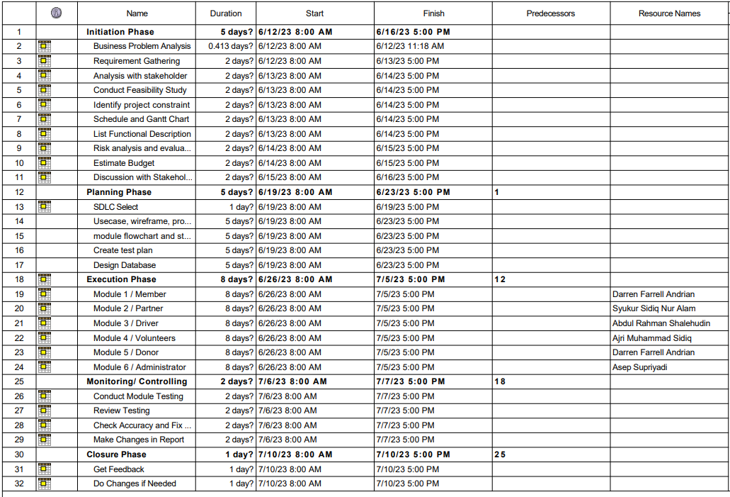

**Progress Chart**

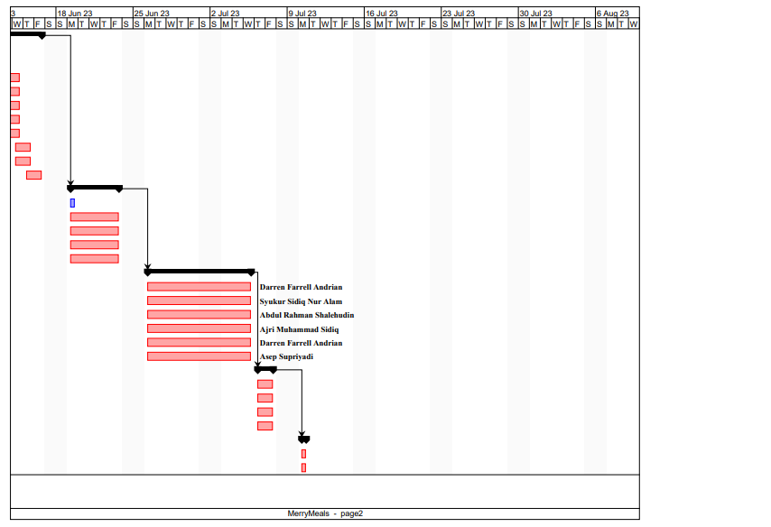

1. **Detailed Plan – at the features level**

my detailed plan is for handling partner functionality includes implementing partner registration, developing a secure login system, creating a view for partners to see ordered meals, and implementing the process to process ordered meals based on Meals on Wheels specifications. This involves gathering requirements, designing user-friendly interfaces, developing backend logic, incorporating security measures, and integrating necessary functionalities to ensure a seamless experience for partners in registering, accessing their accounts, viewing orders, and efficiently processing meals.

1. **UML & Flow Chart**
   1. **UML**
      1. **Use Case Diagram**

The use case diagram will visually represent the functionalities and interactions of the Meals on Wheels application. It will help identify and document the different actions users can perform and how they interact with the system. The diagram will provide a clear overview of the system's behavior and requirements, ensuring that the development team can design and implement the application accordingly. It will facilitate communication and collaboration among stakeholders, fostering a shared understanding of the system and enabling discussions and refinements to align with Meals on Wheels business goals.

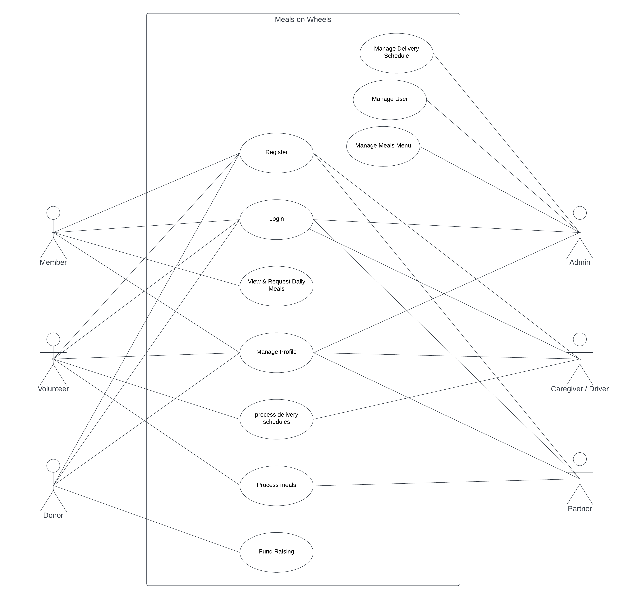

* 1. **Flowchart / Storyboard**
     1. **Partner Functionality**

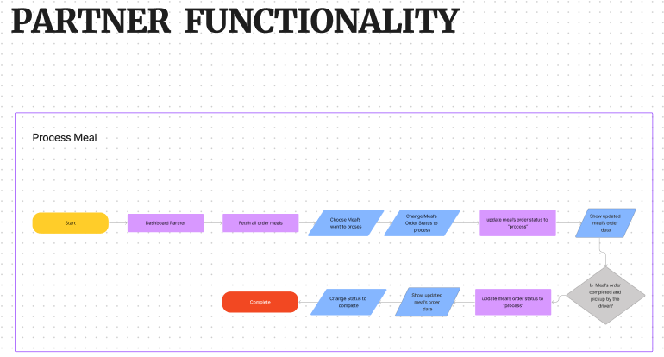

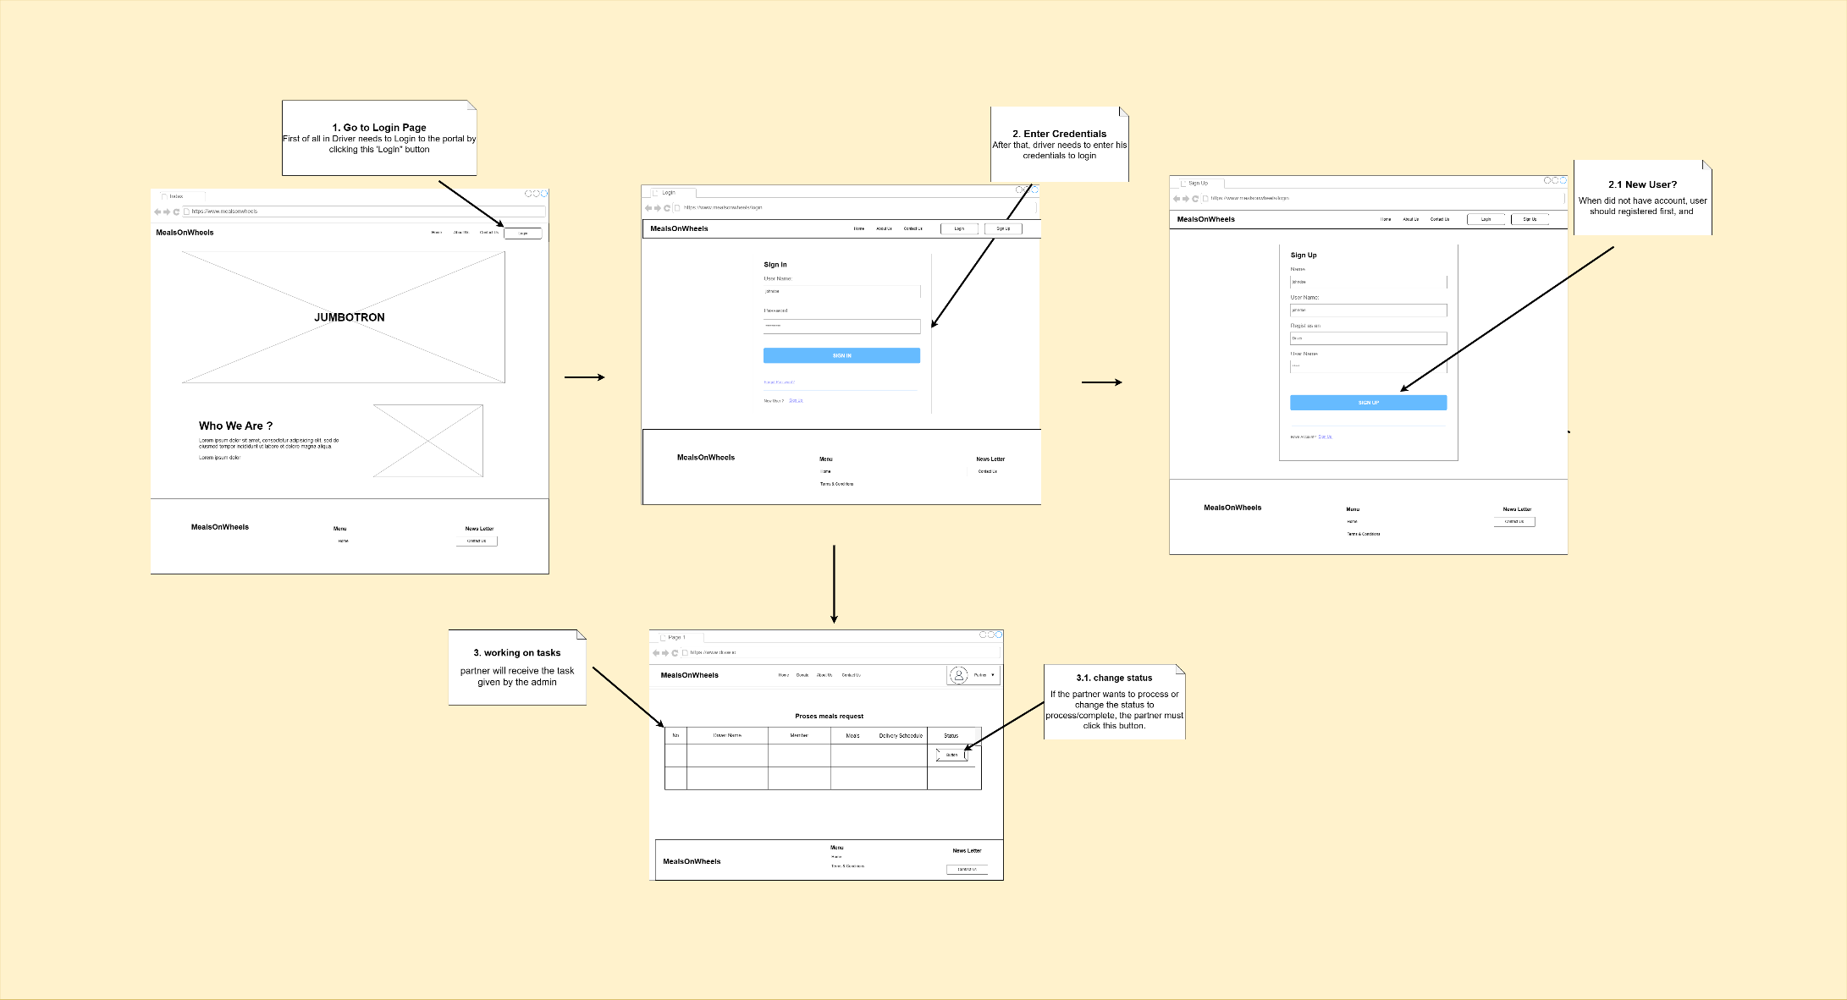

1. **Project Test Planning** 
   1. Food Safety Management Test plan

We will conduct various tests to evaluate our project's performance and ensure it meets the required standards. The testing process includes Unit Tests to check individual components, User Acceptance Testing to assess user satisfaction, Performance Testing to measure system performance, and Compatibility Testing to ensure the application runs smoothly on different devices and platforms. These tests will help us validate the project's functionality, usability, and overall quality.

* + 1. The testing plan for the Meals on Wheels portal includes the following testing

1. Functional Testing - UAT test cases - 4 atleast
2. Compatibility - Cross-browser testing / responsiveness
3. Performance Efficiency - Load Testing/ Stress testing
4. Portability - Multi platforms (different platforms, different devices)
   * 1. Test Plan Table
5. Test Scenario
6. Test Cases (Under one scenario, there may be more than one test cases)
7. Test Objectives
8. Expected Outcome
9. Risk
10. Techniques (Types of testing)

|  |  |  |  |  |  |  |  |
| --- | --- | --- | --- | --- | --- | --- | --- |
| Risk Id | Test Scenario ID | Test Scenario | Test Objective | Test Priority | Risk | Technique | Expected Result |
| 1 | TS001 | Validating Registration as a Partner funtionality | For Partners to successfully register with their credentials. | High | partner cannot create an account if there is a similarity in the email | Unit Testing | After registering user will see the succes message and their credentials saved in the database |
| 2 | TS002 | Validating Login as a Partner functionality | To check Partner credentials are existing in the system. | High | Partner is not able to log in to the portal | Unit Testing | After login, user will reach to the home page |
| 3 | TS003 | Ensure the functionality of the ordering process | to ensure that orders can be processed. | High | Partner not being able to proceed food | Unit Testing | After checking, junit should return a pass result because the selected food data can be processed.  Ensure Retrieval Menu functionality. |
| 4 | TS004 | Ensure the functionality of the Retrieval Menu | so that partners can see the daily menu | High | partners cannot see the daily menu | Unit Testing | after checking, junit should return a pass result because the daily menu can be seen. |
| 5 | UA001 | Ensure partner registration functionality. | To allow users playing the role of partners to successfully register using their credentials | High | Partners cannot create an account if there is an email similarity | User Acceptance Testing | After conducting the testing, UAT should return the appropriate result if partners can register successfully using their credentials. |
| 6 | UA002 | Ensuring the partner login functionality | To allow users playing the role of partners to log in to the portal using their credentials | High | Partners are not able to log in to the portal | User Acceptance Testing | After conducting the testing, UAT should return the appropriate result if partners can log in to the portal using their correct credentials. |
| 7 | UA003 | Ensuring the ordering process functionality. | To allow partners to successfully place orders. | High | Not being able to order food. | User Acceptance Testing | After conducting the testing, UAT should return the appropriate result if partners can successfully processed the order |
| 8 | UA004 | Ensuring the Retrieval Menu functionality | allow partners to view the daily menu that needs to be prepared. | High | Partners cannot see the daily menu. | User Acceptance Testing | After conducting the testing, UAT should return the appropriate result if partners can view the daily menu as expected. |
| 9 | PM001 | Testing the performance of Partner dashboard page | To utilize the page’s loading speed of the Partner dashboard page using Chrome DevTools | Extreme | Partner will have a difficulty for managing the application process properly | Performance Testing | After testing, The loading time speed should be above 80 – 90% or less than 1s. |
| 10 | CB001 | Ensure Login page maintain a consistent look and feel in different browser (Chrome, Edge, Firefox) | To check a consistent look and feel of the login pageacross different browser | High | The Partner may feel confused with the different look and feel in the login page so partner may have a difficulty for logging in to the portal | Compatibility Testing | After testing, Login page maintain a consistent look and feel across different browser |
| 11 | CB002 | Ensure Partner dashboard page maintain a consistent look and feel in different browser (Chrome, Edge, Firefox) | To check a consistent look and feel of the Partner dashboard page across different browser | High | The Partner may feel confused with the different look and feel in the dashboard page so Partner may have a difficulty tracking the order in the portal | Compatibility Testing | After testing, dashboard page maintain a consistent look and feel across different browser |
| 13 | PB001 | Ensure dashboard page maintain a consistent look and feel in different devices (laptop, iPad, phone) | To ensure all feature in the dashboard page is visible to the Partner in different devices | High | Partner may feel difficulty to chose a different option as the website are not able to adapt to their device of choice | Portability Testing | After testing, all dashboard page is visible to the Partner in different devices (laptop, iPad and phones) |